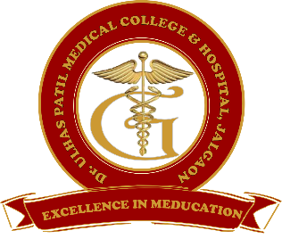**Godavari Foundation’s**

**DR. ULHAS PATIL MEDICAL COLLEGE & HOSPITAL,**

**Recognized by Medical Council of India, Approved by Central Govt. of India, New Delhi,**

**Letter no. MCI-34(41)/2012-med./158127, dated 05/02/2013**

**Affiliated to Maharashtra University of Health Sciences, Nashik [College Code-1306]**

**Jalgaon-Bhusawal Road, NH-6, Jalgaon Kh, Tal. & Dist. Jalgaon 425309**

**Tel. No. (0257)2366657, 2366678 Fax No. 0257-2366648**

**Email ID :** [**dupmcj@yahoo.in**](mailto:dupmcj@yahoo.in) **Web Site :** [**www.dupmc.ac.in**](http://www.dupmc.ac.in)

**4.3.1 Library is automated using Integrated Library Management System (ILMS)**

DUPMC is having well established Library as per statutory and regulatory requirements for students and teaching staff.

* We have Godavari Foundation online library management system, which is developed by our own software development cell.
* Till date the library management system is **partial** Automation.
* The library management system was introduced in March 2022 and will be fully automated in March 2023.
* The developed software is VB dot net SQL based server system with cloud computing support
* Overall development facility of this software and maintenance is taken care by the special ICT team

Library automation is the application of ICTs to library operations and services. The Godavari Foundation LMS provides all the functions related to Library. An integrated library management system is a computer-based system for internal as well as external use of library resources.

It is simplifying the various tasks of library such as acquisition of books, cataloguing of books and issue and return process commonly done in the library.

The library management system allows a library to keep track of all its books, and also manage its members. Some of the services offered by a library management system include book request by the members of the library, and denial or issuance of the request by the librarian.

The system has several modules that serve various functions.

* Master Section
* Issue Section
* Return Section
* Report Section

The Godavari Foundation LMS system provides various open access E-resources on the home page of the software. It can be remotely access from anywhere.

* E-Resources like: National Digital Library of India, e-pgpathshala,Vidya Mitra, Sage Journals, OAJSE etc.
* E-Dictionary like: Cambridge Dictionary, Art Dictionary, Oxford Reference, Merriam Webster etc.
* E-News Papers : All the leading newspapers (Local as well as National)

The librarian can issue or return books into the library management system, and can conduct searches on members and books in the system.

The librarian also has add or delete function, which allows the librarian to add or delete member and staff accounts, and manage books in the library management system.

The librarian’s interface, can access includes adding or deleting a member, adding or deleting a book, searching and viewing member accounts, searching and viewing book details, and issuing or returning a book.